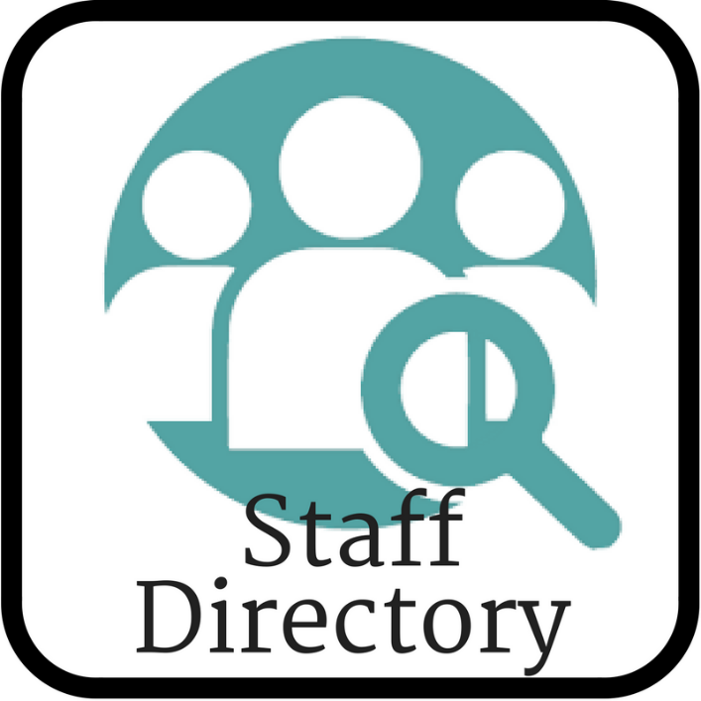
Hello Etheredge Team!
We were thinking how awesome an employee directory would be!

And Open Enrollment seemed like a great time for you to update your information for our systems. I know folks have moved, changed phones, gotten married….. So sometimes it’s hard for me to reach you.
As for the employee directory, it’d be accessible only to employees on our new Employee Portal! So for new hires, it’d be a great tool to familiarize yourself with who people are and the who works in what department. Each location can quickly see the contact info for someone at another location. It’s a great way to get to know more about each other!
So please, take a moment and update your information for me, and let me know if it’s okay to include you in our Etheredge Employee Directory.
Watch for more information coming your way as our employee portal grows!

